标题：Human in the Loop Automation: Ride-Hailing with Remote (Tele-)Drivers
作者及机构:
Saif Benjaafar: Department of Industrial and Operations Engineering, University of Michigan, Ann Arbor, Michigan 48109
Zicheng Wang: School of Data Science, The Chinese University of Hong Kong, Shenzhen, Guangdong 518172, P.R. China
Xiaotang Yang: Department of Industrial and Systems Engineering, University of Minnesota, Minneapolis, Minnesota 55455
摘要: Tele-driving refers to a novel concept by which drivers can remotely operate vehicles (without being physically in the vehicle). By putting the human back in the loop, tele-driving has emerged recently as a more viable alternative to fully automated vehicles with ride-hailing (and other on-demand transportation-enabled services) being an important application. Because remote drivers can be operated as a shared resource (any driver can be assigned to any customer regardless of trip origin or destination), it may be possible for such services to deploy fewer drivers than vehicles without significantly reducing service quality. In this paper, we examine the extent to which this is possible. Using a spatial queueing model that captures the dynamics of both pickup and trip times, we show that the impact of reducing the number of drivers depends crucially on system workload relative to the number of vehicles. In particular, when workload is sufficiently high relative to the number of vehicles, we show that, perhaps surprisingly, reducing the number of drivers relative to the number of vehicles can actually improve service level (e.g., as measured by the amount of demand fulfilled in the case of impatient customers). Having fewer drivers than vehicles ensures that there are always idle vehicles; the fewer the drivers, the likelier it is for there to be more idle vehicles. Consequently, the fewer the drivers, the likelier it is for the pickup times to be shorter (making overall shorter service times likelier). The impact of shorter service time is particularly significant when the workload is high, and in this case, it is enough to overcome the loss in driver capacity. When workload is sufficiently low relative to the number of vehicles, we show that it is possible to significantly reduce the number of drivers without significantly reducing service level. In systems in which customers are patient and willing to queue up for the service, we show that reducing the number of drivers can also reduce delay, including stabilizing a system that may otherwise be unstable. In general, relative to a system in which the number of vehicles equals the number of drivers (as in a system with in-vehicle drivers), a system with remote drivers can result in savings in the number of drivers either without significantly degrading performance or actually improving performance. We discuss how these results can, in part, be explained by the interplay of two counteracting forces: (1) having fewer drivers increasing service rate and (2) having fewer drivers reducing the number of servers with the relative strength of these forces depending on system workload.
AI标题: 远程驾驶重构供需模型：资源池化实现人车效率跃升
AI精炼: 这篇论文研究了共享出行领域的运营效率优化问题，旨在解决传统网约车中“司机与车辆一对一”模式带来的成本过高和供需错配问题。过去研究多通过动态定价、匹配半径策略或自动驾驶技术缓解供需矛盾，但全自动驾驶落地困难，而作者提出了一种创新方案：利用远程驾驶技术实现“司机与车辆解耦”，使少量远程司机可灵活调配多辆空闲车辆。 通过建立空间队列模型，作者发现远程驾驶系统存在两种动态效应：减少司机数量会缩短车辆接载时间（因空闲车辆增多），但同时也降低服务容量。其核心结论颠覆直觉——在高负荷场景下，减少司机反而能提升服务完成率，因为接载效率的提升抵消了司机不足的损失；而在低负荷场景中，司机数量可大幅缩减而不显著影响服务质量。对耐心用户，远程驾驶甚至能通过平衡接载速度与服务能力，将不稳定系统转为稳定状态。该研究为共享出行平台提供了一种通过“人车资源池化”实现降本增效的新思路。
关键词:
远程驾驶系统
空间队列模型
人车资源池化
状态依赖服务时间
多服务器队列系统
野鹅追逐效应
服务级别优化
延迟稳定机制
学术要点: 学术要点 1：人机协同自动化（Human-in-the-Loop Automation） 通过远程驾驶员持续参与车辆控制，在自动化系统中保持人类决策的闭环，平衡技术局限性与安全需求。|||
学术要点 2：空间队列模型（Spatial Queueing Model） 结合地理空间特征的队列模型，动态捕获接送时间与行程时间的相互影响，用于分析车辆供需匹配效率。|||
学术要点 3：供给受限/中间/富足三态（Supply-Limited/Intermediate/Rich Regime） 基于车辆与工作负载比例划分的系统状态，揭示驾驶员数量对服务水平的非单调影响机制。|||
学术要点 4：状态依赖服务速率（State-Dependent Service Rate） 服务速率随空闲车辆数量动态变化，空闲车辆越多接送时间越短，形成服务能力与资源占用的反直觉耦合。|||
学术要点 5：野鹅追逐缓解效应（Wild Goose Chase Mitigation） 通过远程驾驶员共享池机制减少无效长途调度，改善传统网约车中供需空间错配引发的效率损失。
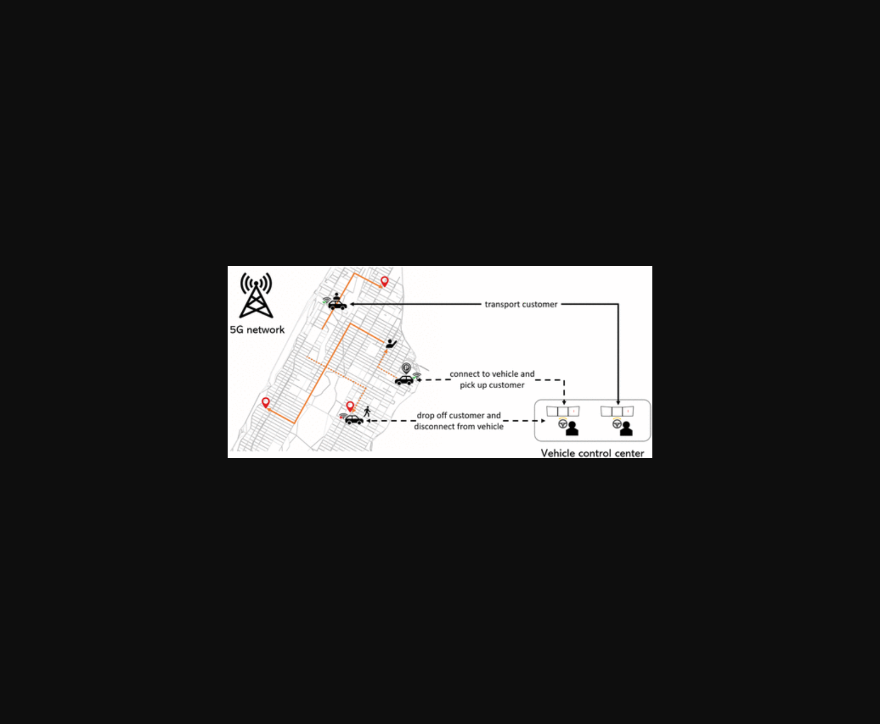
图示远程驾驶系统中驾驶员与车辆配比变化对服务效率的影响趋势。
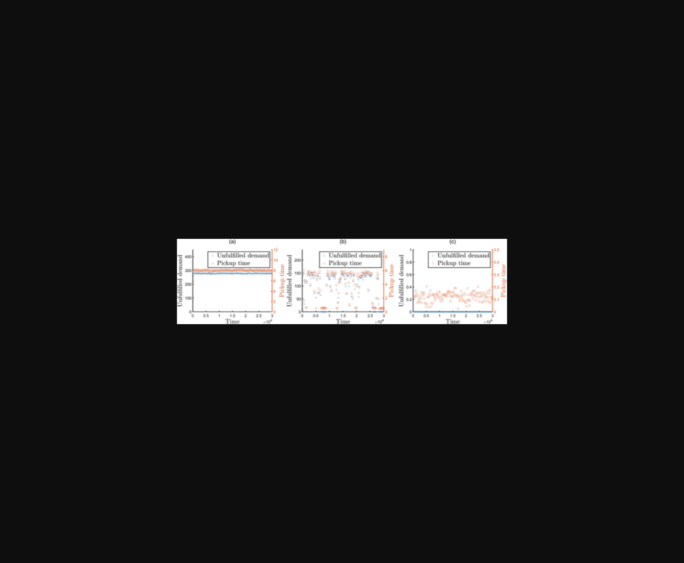
图片通过空间排队模型展示了驾驶员与车辆配比对服务效率的影响。
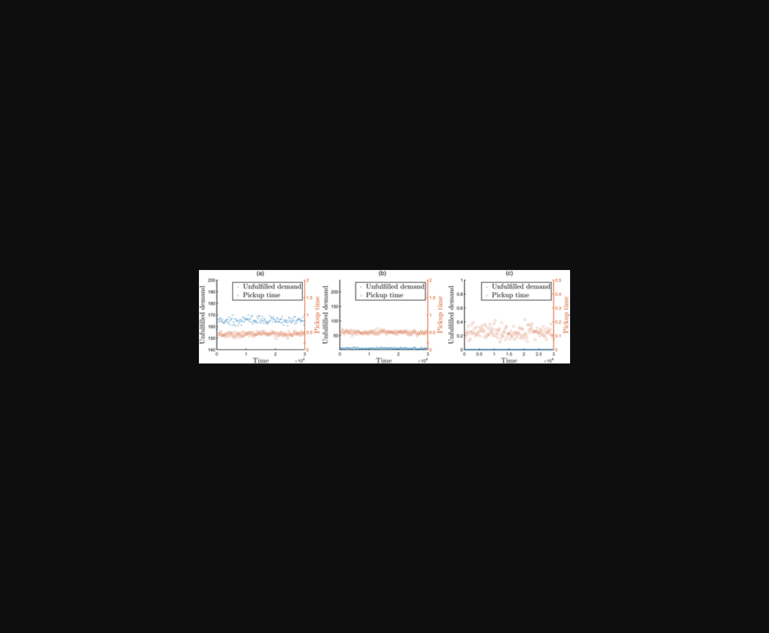
该图展示了远程驾驶系统中驾驶员与车辆数量比例对服务效率的动态影响。
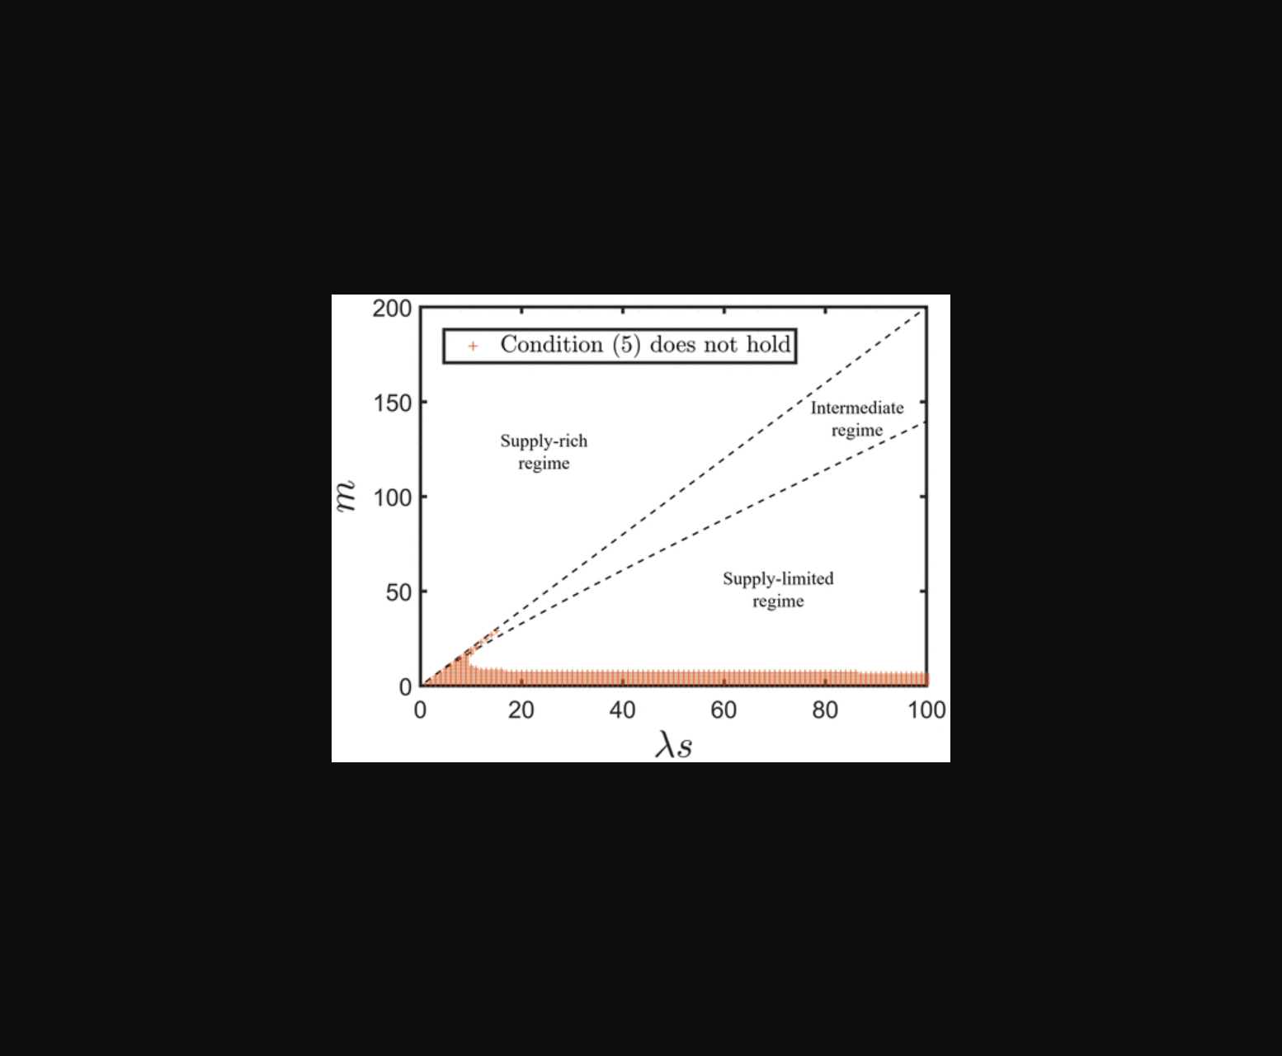
图片展示了不同驾驶员与车辆配比下系统服务效率随工作负载变化的对比曲线。
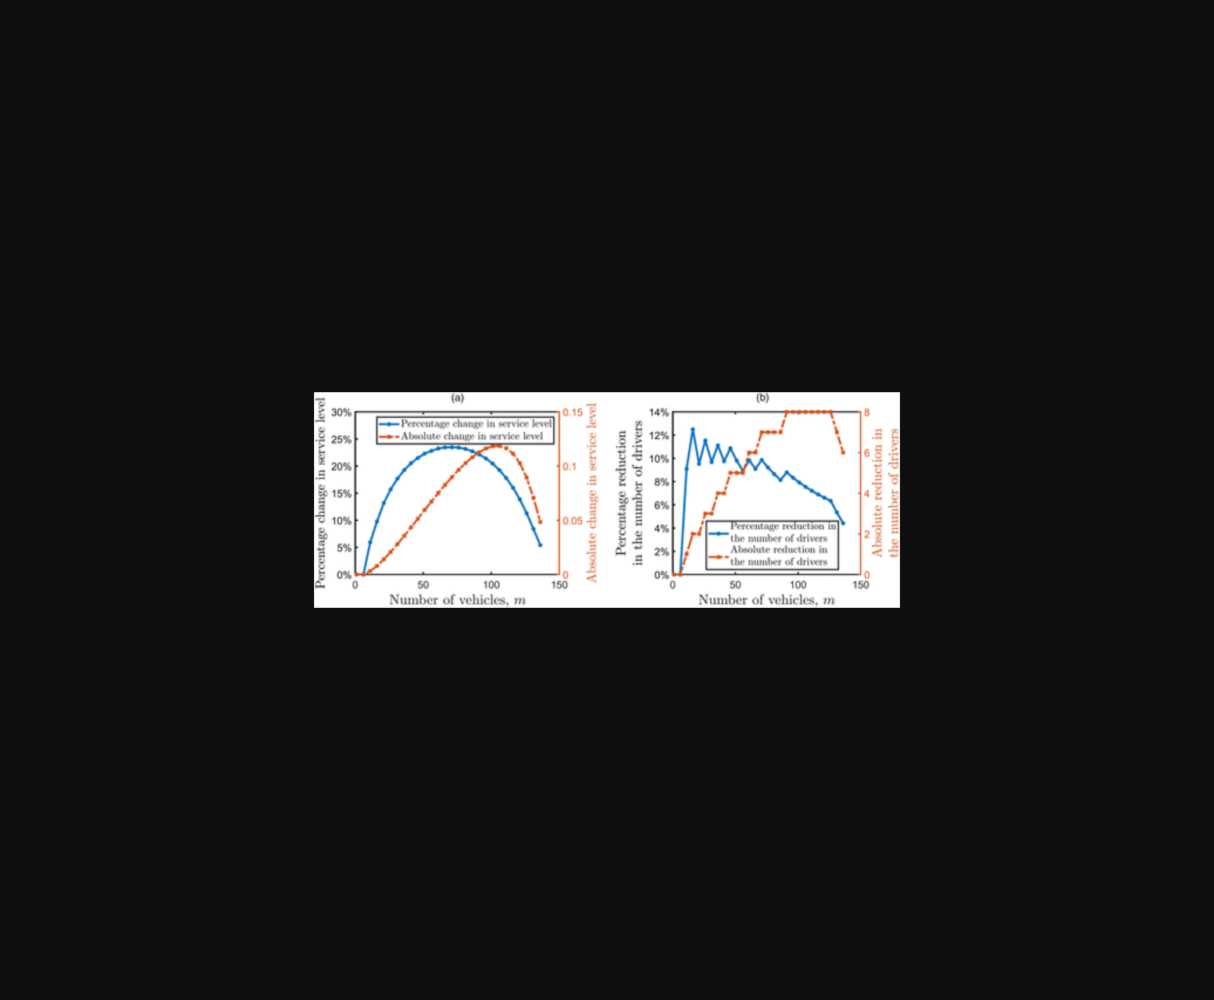
图片展示了远程驾驶系统中驾驶员与车辆比例对服务效率的动态影响。
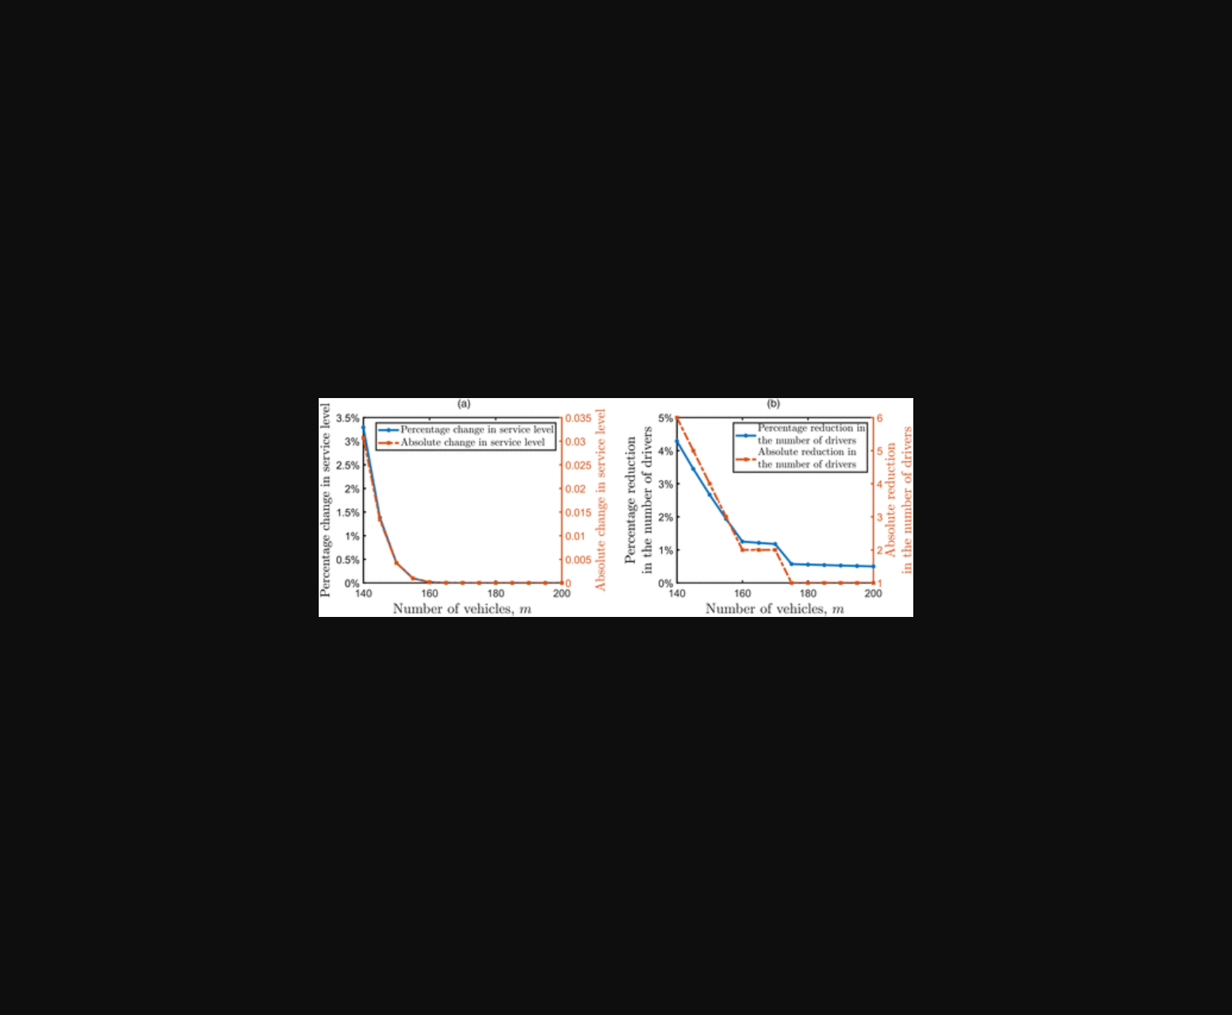
该图通过队列模型展示了远程驾驶系统中驾驶员与车辆配比对服务效率的影响。
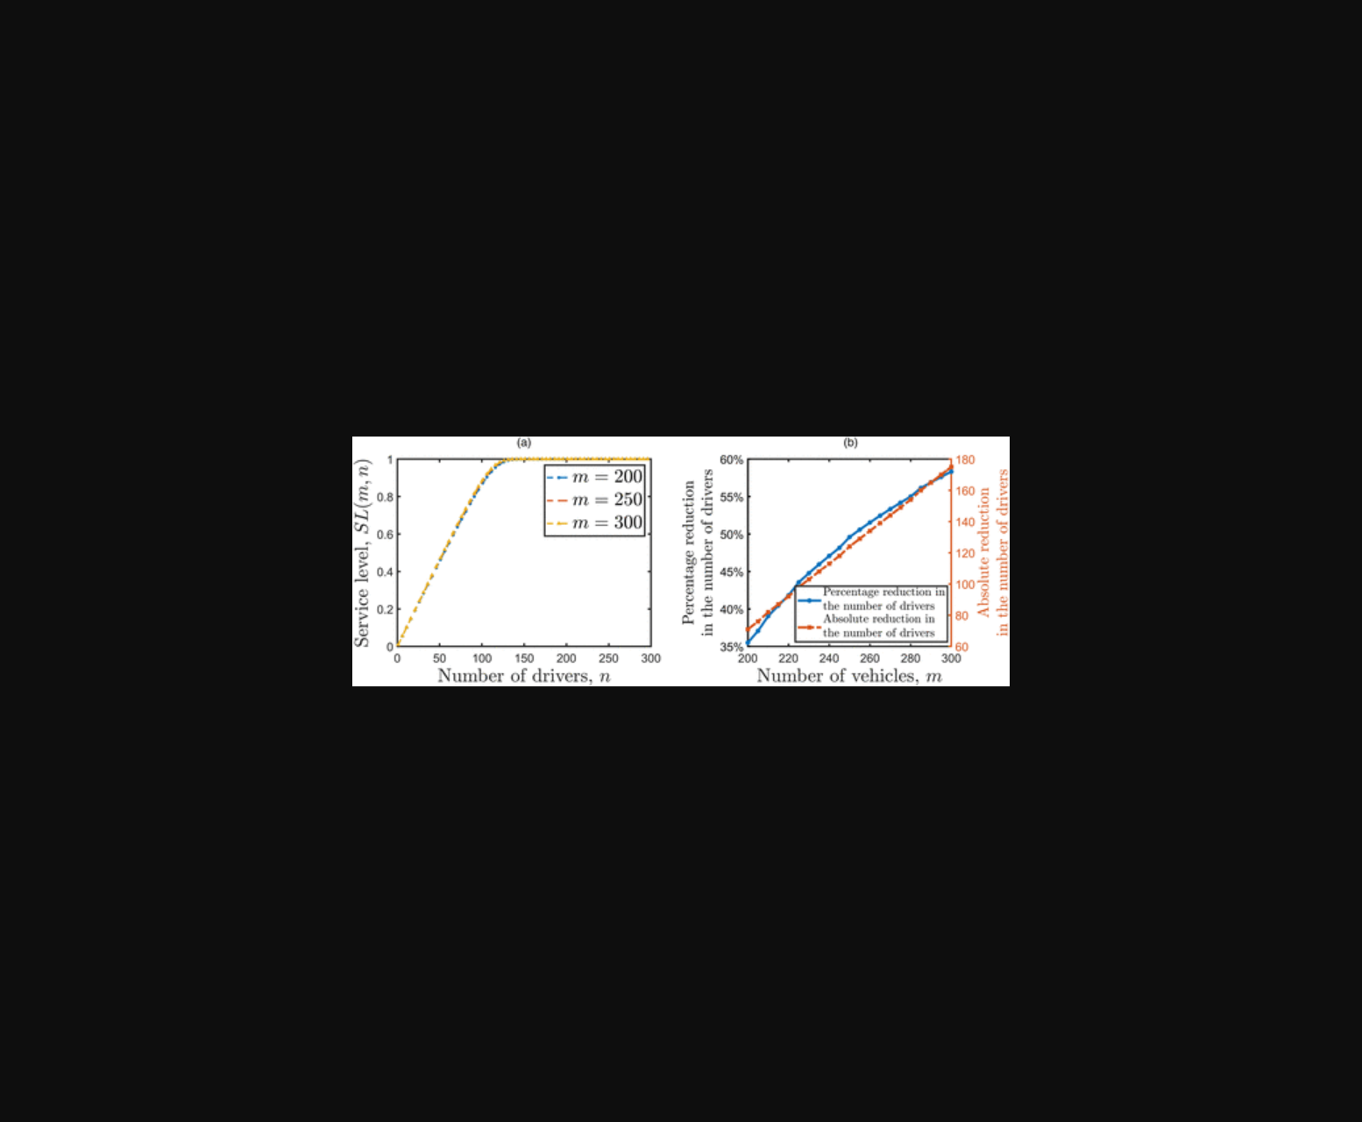
图片展示了远程驾驶系统中车辆与驾驶员数量配比对服务效率的影响模型。
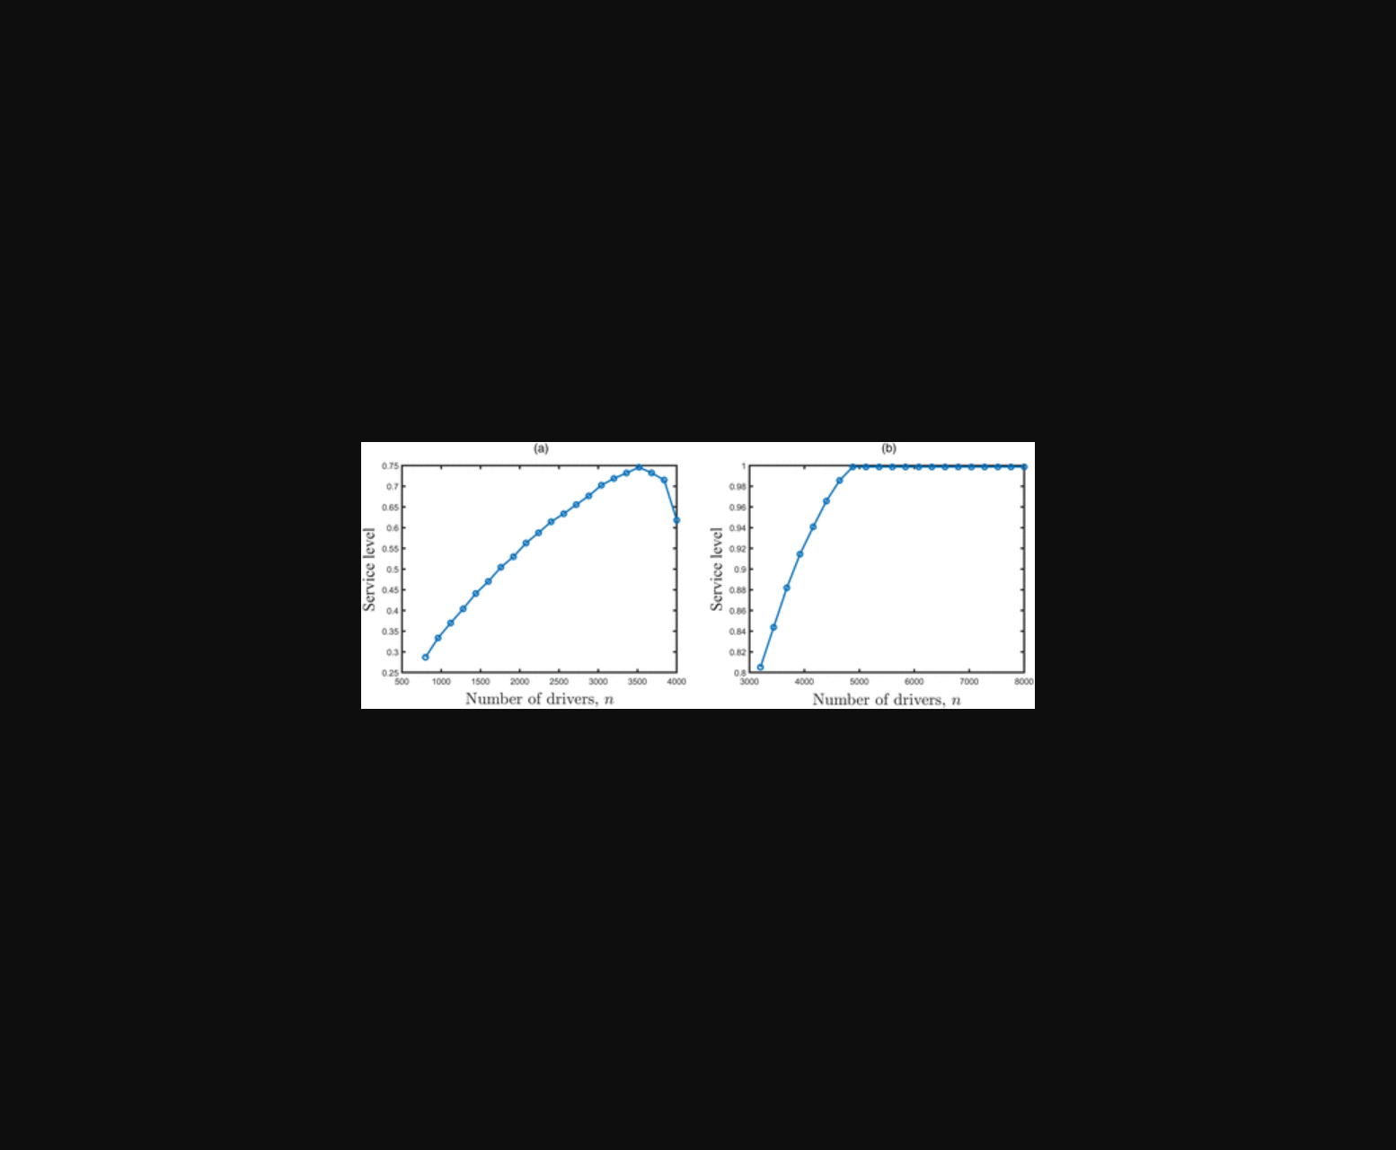
图片展示了远程驾驶系统中司机与车辆配比对服务效率的影响，对比分析了高低负荷下的性能差异。
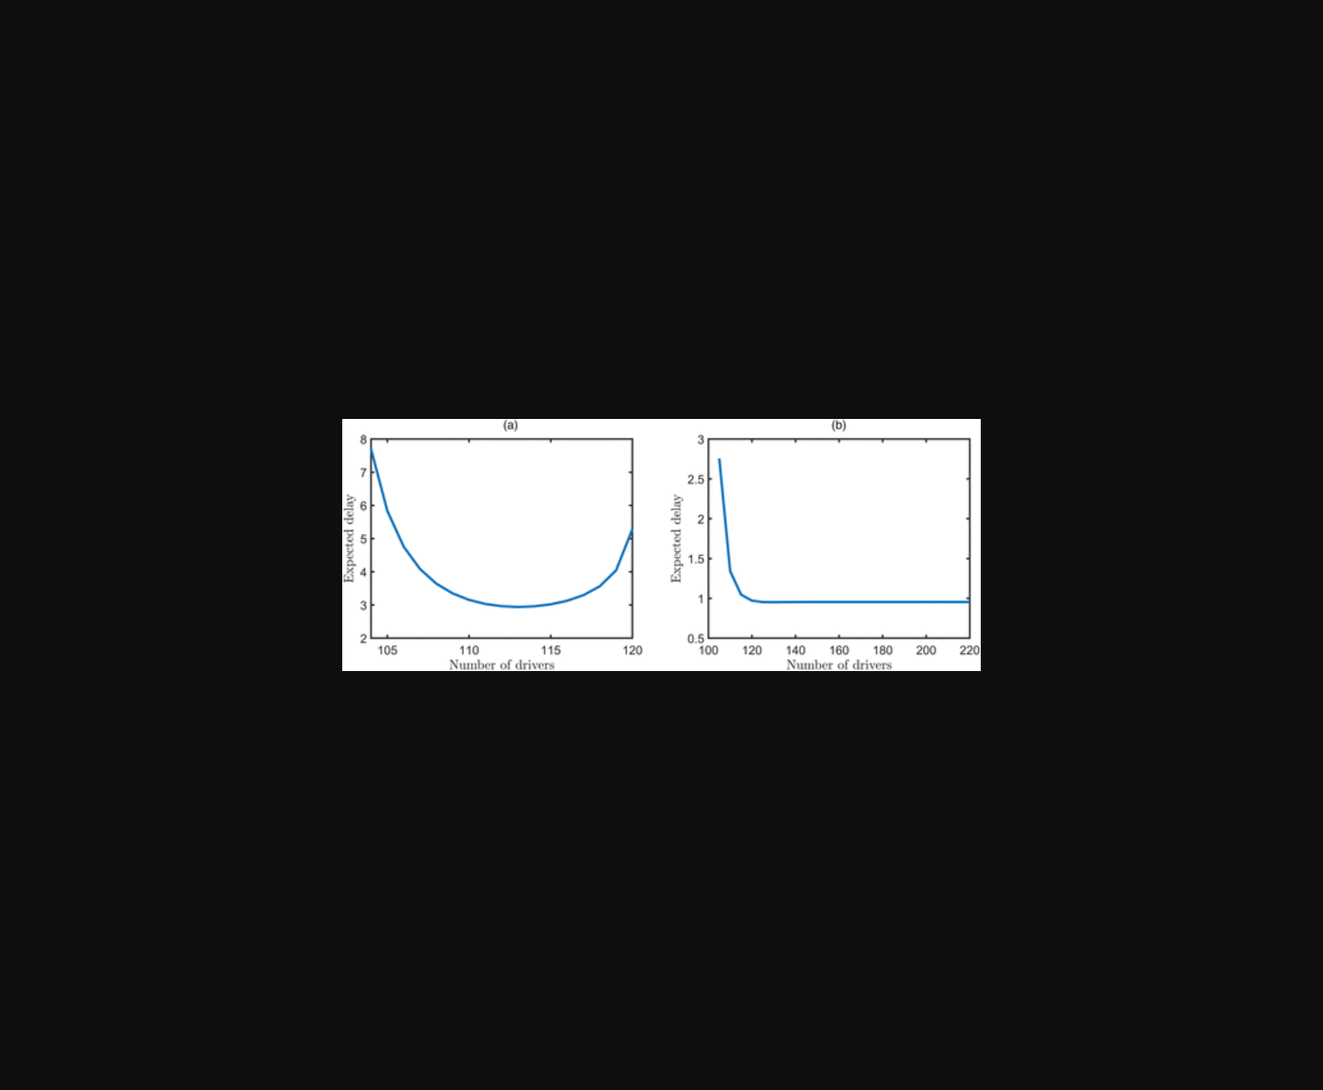
图示远程驾驶系统中车辆/司机配比与系统负载的动态关系模型。
原文链接: https://doi.org/10.1287/mnsc.2022.01687

